Entré Operator’s Quick Reference

The most commonly-used operator functions in Entré typically involve user codes and swipe cards, user profiles, schedules, reports, and occasional manual control of burglary and door-access elements. This guide will serve to provide simple instruction on these items, and will help to get you quickly familiarized with Entré for common tasks. Before we jump into Entré programming, however, it’s helpful to know how the control panel behaves, and what the significant differences are between keypad user-menu programming and Entré programming.

How the panel processes user codes:
The DMP XR100/500N control panel utilizes user codes both for keypad functions and card-access functions. You can think of a user code as merely a credential. The actions that any credential can perform are dictated by its permissions, such as gaining access to the keypad menu, arming and disarming of burglary areas, and card-access. Those permissions are established in a user code profile. A profile permits creating user codes for groups of people who have the same set of permissions, and it shortens programming time and makes tracking and reporting easier. The panel itself supports only one credential per user code record, and only one profile assignment per credential. If a user needs more than one credential, they will need multiple user code records within the panel.

When a person uses their credential at the keypad, their profile permissions say what they can/can’t do at that keypad, such as arm, disarm, or enter the user menu. When a person uses their credential at a card reader, their profile says whether or not the door will unlock. Although profiles can be created that will allow a user to do all of these things with just one credential, in some circumstances, it may be necessary for a person to have multiple credentials and/or multiple profiles such as a person who needs a swipe card and a 4-digit keypad code.

Creating a user code in the DMP panel from a keypad or System Link™/Remote Link™ requires that the user code record contain four pieces of information:
User Number (this is the “slot” where the user code record is stored in the panel)
User Name (Unformatted, 32-character field that defaults to user number)
User Code (keypad code or internal swipe card code)
Profile Number (the existing profile that defines this code’s permissions)

The user code’s profile number must belong to an existing profile, or the code will be useless. Creating a user code profile in the DMP panel from a keypad or Remote Link requires that the user code profile record contain two pieces of information:
Profile Number (this is the “slot” where the profile record is stored in the panel)
Profile Name (Unformatted, 32-character field that defaults to profile number)
The permissions granted to/excluded from that profile (arm/disarm/door-access, etc.) are selectable within the profile programming menu.

In summary, in order for a person to be able to perform an action with a credential, or a “credential-based event”, they need to have a valid user code record linked to a valid profile record. In the panel, this is only two sections of programming that in total contains six pieces of information in addition to the individual profile permissions. If a person needs to have two credentials, say one for arming and disarming at an interior keypad, and one for a door-access swipe card, they might need two user code records (keypad code and prox card code) and two profiles (arm/disarm burg areas, and access door areas).

How the panel processes schedules and holidays/exceptions:
The DMP XR100/500 control panel has the ability to use scheduling to automatically arm and disarm protected areas, restrict access to doors by defined shift times, lock and unlock doors, and turn outputs on and off. It allows the end-user programmer to create a “looping” 7-day schedule for each area, shift, door, and output. “Holiday Dates” allow provision for making exceptions to those schedules up to 365 days in advance – it can be thought of as a 1-year calendar inside the panel that overrides any running schedule on the holiday dates programmed in to it.

When a protected area needs to be armed/disarmed by a schedule, a single schedule can be created for that “burglary area”. If multiple burglary areas need to be armed/disarmed via schedule, a dedicated schedule will need to be created for each burglary area.

When a profile needs to have its access restricted by time, or “shift”, what it’s restricting is when they can access doors in certain access areas. Therefore, creating area shift schedules for those access areas, and setting the corresponding shift number in their profile will cause the panel to deny them access if they attempt to access outside of that schedule.

Auto-arming/disarming and shift access schedules are “Area Schedules” – they are merely a running timer that is tagged to an area. What makes an area schedule an auto-arm or a shift access schedule is determined by whether or not the area itself has auto-arm/disarm turned on, or if the area exists in a profile’s access areas and the profile has a shift number selected. The panel supports creation of up to a maximum of four schedules per area for auto-arming and shift access, and all “Start” times must be accompanied by an “End” time.

Automatically locking/unlocking doors and turning outputs on and off requires creation of a different kind of schedule – an “Output Schedule”. An output schedule, like an area schedule is a looping 7-day timer. A dedicated schedule needs to be created for each door/output that will be automatically controlled. Up to eight output schedules can be created and assigned to a single door/output, which means that a single door or output could have up to eight lock/unlock or on/off events in a single day, seven days a week. Unlike area schedules, an “on” time does not need to be accompanied by an “off” time – this allows you to turn something on up to eight times a day via schedule, if necessary, without turning it off and vice-versa.

Since the panel schedules are looping 7-day timers, telling areas to stay armed and doors to stay locked on a holiday in the middle of the week would require manual deletion of those days in each relevant schedule the week of or before the holiday date(s), then manual re-entry of those days the week after. Instead of having to do that, the user can program up to 20 days worth of 24-hour exceptions called “Holiday Dates” into the panel’s holiday calendar up to 365 days in advance. Merely creating the holiday date within the panel will immediately cause the 24-hour exception to affect all running schedules on that day.

It’s also possible to create an exception to the exception, so to speak. What if the holiday is a half-day off? What if some schedules need to be affected while others do not? The panel allows a holiday date to be defined as a “Type A, B, or C” holiday date. This lets the programmer to go into each schedule and tell it how the 24-hour exception should affect it, definable by time. For instance, if an auto-arm schedule in area 1 needed to be able to ignore the holiday exception and still function on its schedule, it could be told that “Type-A” holidays should be ignored from 00:00 - 23:59.

What to know about keypad/Remote Link™ user code programming vs. Entré user code programming:
The previous section explained how the panel processes user code programming and events. This basic panel knowledge is important for several reasons:
- Programming credentials is significantly different In Entré when compared to keypad/Link because while the panel uses two records (a code record and a profile record), Entré divides the user code record into two new separate records and therefore uses three records in total (a personnel record, a badge record, and a profile record).
- Because of those differences, Entré can intelligently enable assignment of multiple credentials (Entré calls them “badges”) and profiles to a single user record (Entré calls them “personnel).
- Entré DOES NOT CHANGE THE WAY THE PANEL WORKS, so even though a single user can have multiple credentials and profiles in Entré, what it ultimately sends to a panel are a single user code record and a profile assignment for each badge. If a user needs to have multiple credentials in a panel, Entré actually sends multiple user code records to the panel that have the same user name, but each with a different user code number and its associated profile.
- Since Entré can be used to consolidate and administrate the functions of an unlimited number of DMP panels, it has the ability to allow the operator to create a user profile that will work across multiple panels. When a multi-panel profile is created and sent out to the panels, Entré intelligently creates and sends an individual profile to each affected panel.
- Keypad/Link user code programming requires a valid user number for each record. While Entré requires a single unique ID number for every personnel record and a single unique ID number for every badge record, it has the ability to enable one person to have one or more credentials that will work on multiple panels. For this reason, neither the personnel ID number nor the badge number is sent to the panel because user slot number 1 might be available in one panel, but not another. Entré therefore combines data from the personnel record (name) and its badge record(s) (code and profile) to complete the user code record in the panel, and then dynamically assigns it to the panel’s lowest unused user slot (user number). This satisfies all four items of the panel’s user code record requirements.
- Keypad/Link profile programming requires that a profile have a unique number (profile number) and a profile name. Entré does not use profile numbers – only profile names, and each profile name existing in Entré needs to be unique (not duplicated). Because a single profile in Entré can work in multiple panels each with a potentially different number of existing profiles, when a single or multi-panel profile is sent to a panel or panels, Entré dynamically assigns it to the lowest unused profile slot (profile number) in each panel along with the profile name. This satisfies both pieces of the panel’s user code profile record requirements.
- Personnel, badges, and profiles can all be made to be inactive in Entré. Changing an active personnel record to “inactive” in Entré sets that user’s badge(s) profile number(s) to zero in the panel. Changing a badge record to inactive in Entré sets that particular panel user code record’s profile to zero. Disabling a profile in Entré uninstalls it from all affected panels. Affected users in all panels will have user code records linked to a non-existent profile.
- Entré can have a limitless number of personnel/badge/profile records in its database, but it can’t increase the number of users/profiles that the control panel supports.

What to know about keypad/Remote Link™ schedule programming vs. Entré schedule programming:
A previous section explained how the panel processes schedule programming and events. This basic panel knowledge is important for several reasons:
- Programming schedules is significantly different In Entré when compared to keypad/Link because while the panel uses two records (“Schedules” (area) and “Output Schedules”), Entré consolidates those into one record – “Panel Schedules”. It is within each newly-created schedule that the intended use is defined.
- Because of that difference, Entré can intelligently enable assignment of a single area schedule to multiple areas and a single output schedule to multiple outputs/doors, even across multiple panels. This means that if multiple functions (auto arm/disarm, shift restriction) will have the same start and end times, a single schedule with those times can be created and then assigned to those areas. The same can be said for multiple doors and outputs.
- Entré DOES NOT CHANGE THE WAY THE PANEL WORKS, so even though a single schedule can be assigned to multiple areas/outputs/doors in Entré, what it ultimately sends to a panel are a single schedule assignment for each area/output/door.
- Keypad/Link schedule programming allows 12-hour, AM/PM formatting, whereas Entré requires 24-hour time format programming.
- New schedules have to be sent to each affected panel – they do not automatically send. Any changes made to existing schedules will send automatically.
- The verbiage “Holiday Dates” has been replaced with the word “Calendars”. Because Entré has the ability to consolidate and administrate the functions of an unlimited number of DMP panels, it is conceivable that some panels could have different holiday dates than other panels on the system. Therefore, multiple dedicated “Calendars” can be created for a panel or a group of panels the “holiday dates” for each calendar are created within the calendar.
- Merely creating a holiday date from Link or a keypad takes effect immediately. In contrast, calendars must be sent to each intended panel before they will take effect.
- Entré can have a limitless number of schedules in its database, but it can’t increase the number of schedules that the control panel supports.

Getting started programming user codes in Entré – personnel, badges, and profiles
In short, in order for a user code to be created in Entré that actually works on a panel, a valid and active personnel record must be related to a valid and active badge record which is then related to a valid and enabled profile. Since profiles are directly related to badge records and not personnel records, the operator will need to create a badge that is related to both a personnel record and a profile in order for that card/code to work. It’s important to know that profiles and combined personnel/badge/profile records send immediately to panel(s) when saved in Entré!

Step 1 - Creating the personnel record:
After logging in to Entré, navigate to the Management menu and choose “Personnel”. This will open the Personnel module, which by default, only shows active personnel records. To add a single personnel record, click the “Add…” button; this opens the single screen personnel editor wizard. The required fields are:
- First Name
- Last Name
- Unique ID#
Depending on configuration, the ID# may or may not be automatically generated and present. If it is, and you wish to change the number, you may do so as long as long as the new number is unique. Other information can be entered into the personnel record for informational and reporting purposes, as well as a photo ID. If the record is set to anything other than “Active”, it will exist in Entré and in any panels that it was sent to, but it will effectively have a profile number of zero in every DMP panel it exists and will not grant any permissions.

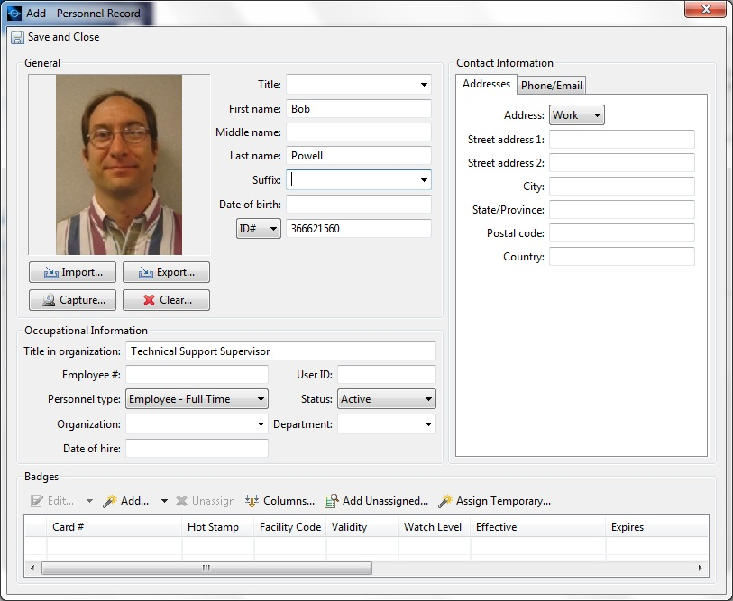

If you were just creating a personnel record for administrative purposes, you could click “Save and Close” to save the record, but we want this personnel record to send to a panel as a user code, so we’ll need to assign a badge…
Step 2 - Adding a new badge to the personnel record within the personnel editor:
- NOTE – remember that a “badge” is merely a numeric credential and can be the internal code of a card used at a reader or a keypad code used for keypad functions like arming/disarming.
The bottom of the personnel editor page shows any active badges assigned to the personnel record. It also provides a shortcut for either adding an existing inactive badge, or adding a new badge. To add a new badge to the personnel record, click the “Add…” button under the “Badges” section at the bottom of the personnel editor; this opens the single screen badge editor wizard. The required fields are:
- Card # (arbitrary number that must be unique)
*(user code is not required for the badge record to exist in Entré, but is required if expected to work in a panel)
By default, the validity is set to “Active”; setting it to anything other than “Active” will cause it to be inoperable in DMP panels. Other information can be entered into the badge record for informational and reporting purposes, as well as a printable badge design template.

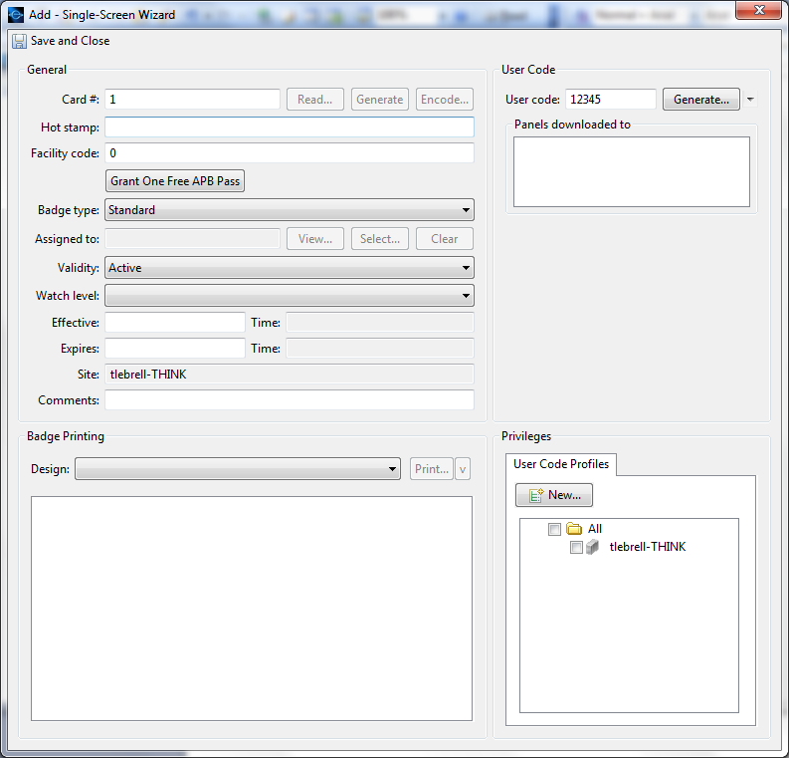

If we clicked “Save and Close” now, we would have a badge record assigned to a personnel record, but the badge would be inoperable, because we have not set its permissions and restrictions yet, so we’ll need to assign a user code profile. We can assign badges to existing profiles in the lower-right section of the window. If the desired profile does not exist yet, we can click the “New…” button to create one…

Step 3 - Creating and assigning a user code profile to the badge from the badge editor:
The bottom-right of the badge editor page shows the list of existing user code profiles. Checking or un-checking a profile associates or disassociates it from the badge. Multiple profiles can be assigned to a badge; however care should be taken when doing so. To add a new profile, click the “New…” button under the “User Code Profiles” section at the bottom-right of the badge editor; this opens the user code profile editor wizard. The required fields are:
- Name # (must be unique)
*(permission items are not required for the profile to exist in Entré, but are required if expected to work in panel(s))
Select the desired permissions for this profile. It is important to know what the profile needs to be able to accomplish before it is created. A profile can arm/disarm burg areas, access door areas, and perform functions at a keypad. Moreover, a single profile in Entré has the ability to be assigned to an indefinite number of panel areas and therefore panels. Sometimes a single profile will suffice for arming, disarming, and door access across multiple panels, but it’s entirely conceivable that a person may need to have multiple profiles for multiple panels to more acutely control their permissions. If the profile is not set to “enabled”, it will exist in Entré but not in any DMP panels.

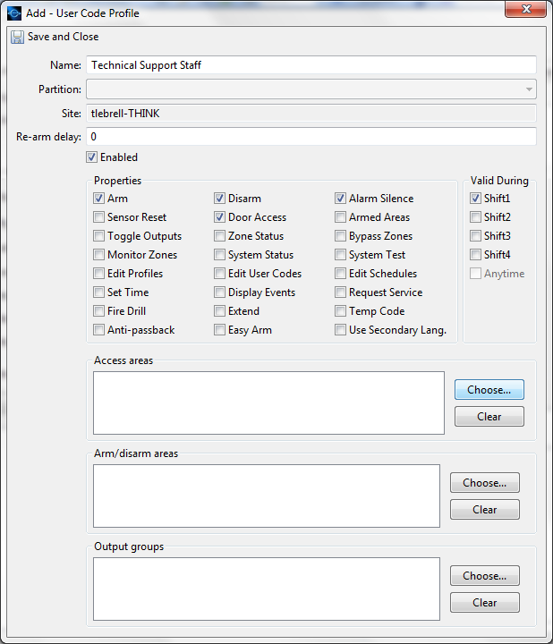

Clicking “Save and Close” will close the window and save the profile, but will not automatically associate it to the badge. In order to do so, merely select the checkbox of the newly-created profile at the bottom-right of the still-displayed badge editor. Clicking “Save and Close” on the badge editor saves the badge and associates the profile(s) to it. Clicking “Save and Close” on the still-displayed personnel editor saves the personnel record and associates the badge(s) to it.

Creating Personnel, Badge, and Profile records independently of each other:
The previous method is useful for adding single personnel records, new badges, and new profiles in a linear start-to-end fashion for single panel users. Personnel, badge, and profile records can also be created and saved independently of each other.

- Adding Personnel: The Personnel module can also be used to store information for non-user personnel (those who do not necessarily need to interact with the security system via credential). To do so, navigate to the Personnel module in the Management menu, click the “Add…” button, and create the personnel record, enter the desired information, and save the record. It will then exist in the database, but will not be active in any panel.

- Adding Badges: Just as non-user personnel can be added to the Entré database, so can inactive swipe credentials. If you order a batch of swipe cards, and would like to not only physically inventory them for later use, but also to virtually inventory them in Entré for tracking and quick-assignment, navigate to the Badges module in the Management menu, click the “Add…” button, and enter a unique value in the Card Number field, enter the card’s internal code, plus any other extra information, then set the badge as “Inactive”. This allows the badge to be saved in the system without being assigned to a user.

- Adding Profiles: Generally speaking, it’s best to create profiles before adding personnel and badges. This is especially true when using the personnel “CSV Import” function to batch-add personnel/badge records (more on that later). To add a single profile, navigate to the Profiles module in the Management menu, and click the “Add…” button. Give the profile an appropriate, unique name, and choose the desired permissions/restrictions. By default, the profile will be selected as enabled. Save and close.

Assigning stored inactive badges to personnel and profiles:
When badges have been virtually inventoried (added) in Entré, they can be assigned to a personnel record and a profile at a later date. It’s important to know that the Badge module does not show/display inactive badges by default, but they can be shown by either choosing “No Filter” from the filter button, or by searching for inactive badges.

- Adding the badge to the personnel record: Open or create the personnel record. In the Badges section at the bottom of the single screen personnel editor, choose “Add Unassigned…”. Unassigned badges must be searched for, because by default, they will not display. Typically, the easiest thing to do is to choose “Inactive” as search criteria and click “Find”. The search can also be narrowed down by adding other filter items. Choose the desired badge and click “Ok”.

- Activating the badge and making the profile assignment(s): The badge will now show up in the list of badges at the bottom of the personnel editor, but it will still be inactive and without profile assignment. Double-click the badge to open the badge editor, set the badge to “Active”, and select the profile(s) the badge will have. Save and close the badge record and then the personnel record.

As stated earlier, profiles and combined personnel/badge/profile records automatically send to panels upon being saved. They will populate the next available user code and profile slots available in a panel (numerically), which will overwrite existing records not put there by Entré. Records having high numbers (profile 99, user 9999) will remain until cleared or overwritten. Manually sending codes and choosing the “Clear” checkbox will remove all existing records and replace them with what exists in the Entré database.
Adding multiple personnel/badge records using the personnel CSV Import Wizard:
It’s possible to add groups of complete personnel records the either have or do not have badge and profile assignments using the personnel CSV wizard. In order to utilize the CSV Import Wizard, however, you must first have the requisite personnel CVS file. CSV (Comma-Separated Value) files are typically either outputted by personnel-management software, or manually created using a text editor (Notepad), or a spreadsheet program (MS Excel).

A CSV file for non-user personnel would only need to consist of the information required by the personnel module – unique personnel number, first name, and last name for each entry. A CSV file for user-personnel would need to consist of those three items in addition to the two items used by the badge record – unique badge number and user code – and the one piece of information required to associate the badge to the profile – profile name (the profile bearing that exact name must exist in Entré before a panel-user CSV record will successfully import, otherwise it will be completely rejected for that reason).

- In the personnel module, click the down-arrow on the right of the “Add…” button and select “CSV Import Wizard…”
- Browse to and select the CSV file. Un-check “File has header row” button if the CSV file does not have a header row. Select the destination where the “rejected-entry” CSV file will be saved.

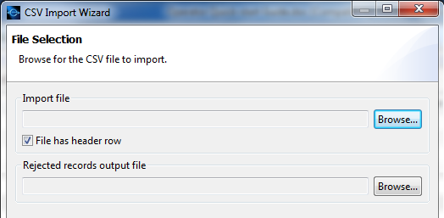

- You will now be presented with the CSV Import Wizard’s Column Configuration editor. This utility is for making sure that the columns of data get sorted to the right fields in the Entré database.

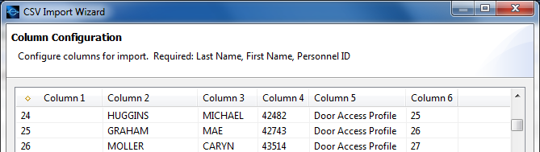

- It will now be necessary to define each column. As stated above, non-user personnel CSV imports require only the last name, first name, and unique personnel ID. For user-personnel imports, however, the record will need those items plus the unique badge ID, the user code, and the name of the profile to be assigned to that badge. Click the numbered column header, and then choose the appropriate corresponding data type in the scrolling list below. In this example, Column 1 would be the unique Personnel ID number, Column 2 would be Last Name, Column 3 would be First Name, Column 4 would be User Code (Badge DMP), Column 5 would be User Code Profile, and Column 6 would be Card #. These named data columns can be saved as a template or “Configuration” to make future CSV imports quicker and easier.

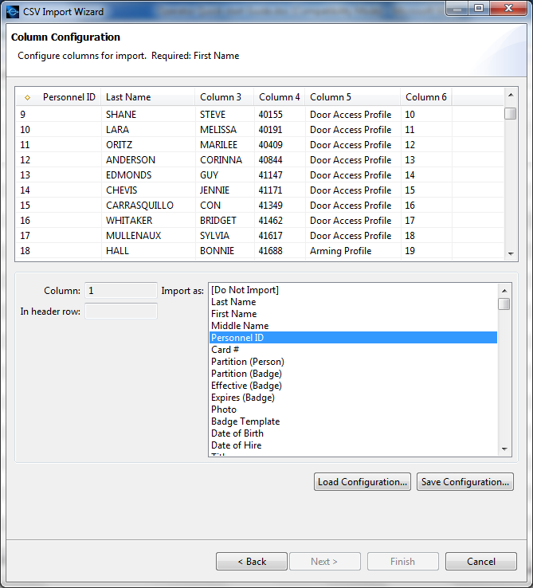

- Click Next to import the data. If any record fails to import, it will show up on the “Invalid Records” tab and will output to the “Rejected” CSV file.

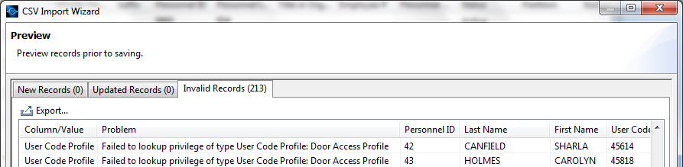
Creating and assigning panel schedules for automatic arming/disarming, shift restrictions, and automatic locking/unlocking

In addition to making multi-panel management easier in regards to user codes and profiles, Entré extends the same convenience of consolidation to arming/disarming schedules, shift-access restriction schedules, and automatic locking/unlocking schedules. Furthermore, if multiple areas, even across multiple panels, have common “start” and “end” times for auto-arming and shift access, one schedule can be created and then assigned to the applicable areas instead of creating multiple schedules with the same time for each area. In like fashion, if multiple access doors have the same lock/unlock schedule times, one schedule can be created for them and assigned to them.

The important thing to remember about any schedule is that even though you have created the schedule, and have possibly given it a meaningful name based on what it’s for, it will not work until it has been assigned to the applicable area/door/output and then sent to the panel.

Specifics about Area/Shift schedules:
- Area/Shift schedules MUST have a start time for every end time and vice-versa – neither the DMP panel nor Entré will accept an area/shift schedule that has an uneven number of start/end times. This is because if the panel automatically arms, it must also have a time that it can be automatically or manually disarmed. It is also because an access shift must have a beginning and an end.
- Changing the “End Day” on a line will effectively move that start time’s end time to that end day. A schedule that has 5 start/end times of 08:00 – 17:00 on days Monday thru Friday is not the same as a schedule that has a start time of 08:00 on Monday and an end time of 17:00 Friday. As such, care must be taken to avoid conflicts with end day overlaps: do not set an end day past the next start day.

Specifics about Door/Output Schedules:
- Door/Output schedules do NOT have to have a start time for every end time. This is so a door lock or output can be triggered and left in that state indefinitely.
- “End Day” is not selectable.

Creating area/shift and door/output schedules:
To create a schedule for automatic arming/disarming, access shift restriction, door locking/unlocking, or output triggering, navigate to the Configuration menu and choose “Panel Schedules” module, and click the “Add…” button. If the schedule is for one specific area/door/output, and no other schedule will be created with the same times, give the schedule an appropriate name, like “Panel 3 Area 4 Special Arm/Disarm”. If the schedule will be “recycled” for other areas/doors/outputs having the same schedule times, you could name the schedule for the days and times for which it is created, such as “8-5 M-F”. Next, choose the appropriate usage type. If the schedule is for auto-arming/disarming or shift access restriction, choose “Area/Shift Schedule”. If the schedule is for automatically locking/unlocking doors or triggering outputs, choose “Door/Output Schedule”. It’s important to remember that once a schedule is saved, although its name and times can be edited, the usage type cannot be changed. Complete the schedule by assigning Start and End times. All times must be entered in 24-hour format. Click “Save and Close” to save the schedule.

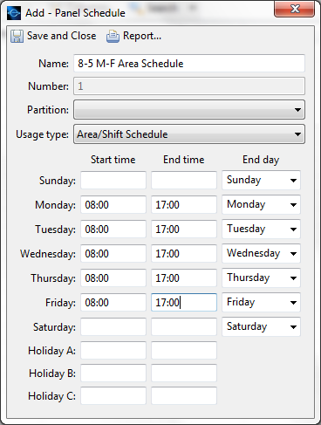

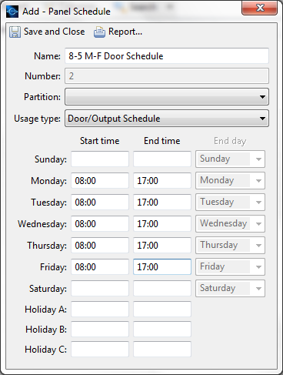
Assigning created schedules to areas, doors, and outputs:
We now have existing schedules created that can automatically control something, and even though we may know exactly what that something is, the DMP panel hardware does not. In order to make a schedule control that something, we first have to assign it to DMP panel hardware in the hardware tree. (This is one of the reasons that areas show up in the hardware tree even though they are not technically physical hardware.)

Applying Area/Shift schedules to areas:
- To apply an area schedule to an area for auto-arming/disarming or shift access restriction, navigate to the Configuration menu and open the Hardware module to display the hardware tree.

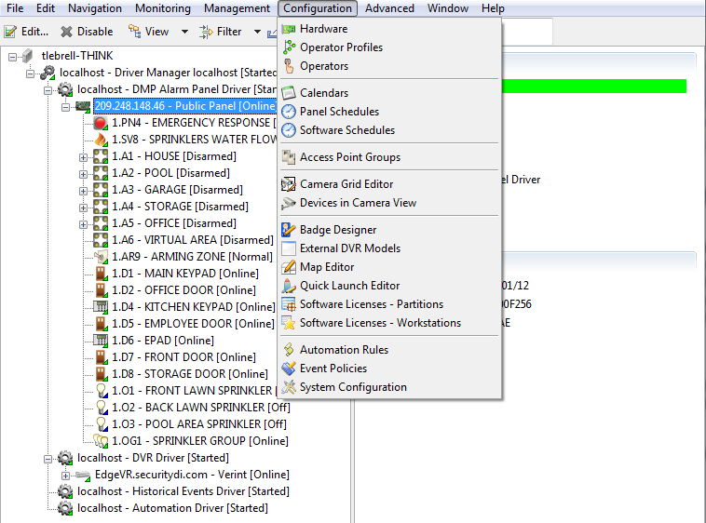

- Double-click the applicable area.

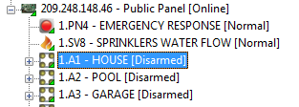

- This will open up that area’s editor. Select “Area Schedules” from the right-hand menu, then click the “Add…” button.

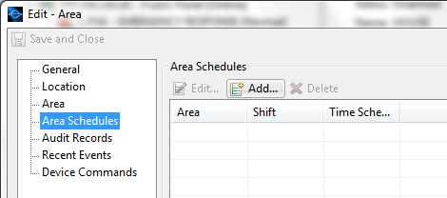

- Choose the desired time schedule. You must choose a shift, regardless of whether this is an auto-arm/disarm schedule or a shift access schedule, because that’s how the DMP panel process all area-type schedules. If this is an auto-arm/disarm schedule, and it’s the first schedule created for this area, you could choose shift 1. If this is indeed a shift access schedule, choose the appropriate shift number that defines this schedule, otherwise it will not operate properly in regards to physical access control attempts at a reader by a person who has a shift restriction number in their profile (more on that later).

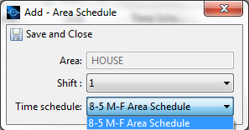

- Click “Save and Close” on the Add – Area Schedule utility and then the Edit - Area utility.

This is a new schedule-related record and will have to be manually sent to the panel(s) it was applied to before it will work in that panel. Furthermore, area/shift schedules are that which can “run” in an area but do absolutely nothing. In order for a running schedule to do something in an area, that something has to be defined by:
- Whether or not the area itself has auto-arm and/or disarm activated.
- Whether or not a profile containing that area as an access area has a shift restriction number (1-4) assigned to it.

Entré will not make assumptions as to what the schedule was intended for, and if auto-arm/disarm was not turned on in a given “burg” area, the schedule will not be able to automatically arm or disarm that area. Likewise, Entré also will not restrict access by shift to a profile that has “Any Time” as a shift. There will be a section later in this guide that will explain how to send new schedule records to the panel(s). There will also be a section later in this guide that will explain panel-user profile permissions, restrictions, arm/disarm areas, and access areas in greater detail.

Applying Door/Output schedules:
- To apply a door/output schedule to a door access device or an output for auto-locking/unlocking or triggering outputs, navigate to the Configuration menu and open the Hardware module to display the hardware tree.

- Double-click the applicable door/output.

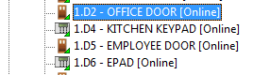

- This will open up that door/output’s editor. For access doors, select “Door Schedules” from the right-hand menu. For Outputs, select “Output Schedules” from the right-hand menu. Click the “Add…” button.

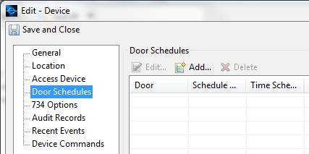

- Choose the desired time schedule. You must choose a Schedule number. If this is the first schedule assigned to this door, choose “1”; if seven schedules have already been assigned to this door, chose “8”.

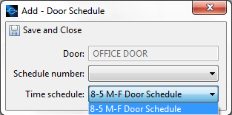

- Click “Save and Close” on the Add – Door Schedule utility and then the Edit - Device utility.

This is a new schedule-related record and will have to be manually sent to the panel(s) it was applied to before it will work in that panel. Furthermore, door/output schedules will not retroactively take affect if the schedule is created/sent to the panel(s) in the middle of the scheduled on and off times. The panel has to “roll in” to an output schedule, so one of two things must be done:
- Manually lock/unlock those doors or turn on/turn off those outputs just for that day.
- Temporarily set the schedule’s “on” time to just-after the schedule is sent to the panel(s), and then revert the “on” time back to its proper time after the panel “rolls in” to the schedule.

It is not recommended to change the panel’s time temporarily, as it may have adverse affects on other scheduled events.

Sending new schedules to the panel
After creating a new schedule record, even though it may have been associated to an area, door, or output, it still has to be sent to the panel(s) in which it will reside. To send schedules to a panel, right click the desired panel in the hardware tree, choose “Panel Configuration”, then “Download Configuration…”, and then choose the “Schedules” checkbox. The status bar will turn yellow while it’s downloading, then turn green when it’s done. Clicking the “Clear Schedules” checkbox below the “Schedules” box will remove all existing records and replace them with what exists in the Entré database.
*Note:
- New area/shift schedules will not take effect until midnight.
- New door/output schedules will have to be “rolled-in to”.
- Making changes to existing schedules and calendars will automatically send to panels.
- Schedules assigned to areas/doors/outputs cannot be deleted from the Panel Schedules module
Creating and assigning panel calendars (holiday dates)

About Calendars (Holiday Dates):
The “Holiday Dates” feature has also been enhanced in that it allows either a single “Calendar” of holiday dates to be created for multiple panels, or a dedicated calendar for each panel. It also allows programming a consecutive string of days for holiday exceptions spanning more than one day (called “Duration”).

Holiday dates serve to provide schedule overrides up to 365 days in advance. When a holiday date is sent to the panel, by default, that holiday date cancels all running schedules (both area/shift and door/output) on that date (24 hours, midnight to midnight). Therefore, areas that would automatically disarm, would not do so. Doors that automatically unlock would stay locked. Holiday dates are also referred to as holiday exceptions.

In many cases, it’s not preferable to affect all schedules on a date. In other cases, it may not be necessary for the exception to be a 24-hour exception (such as a half-day override). These are “exceptions to the exception”, so to speak. If a holiday by default cancels all running schedules on that date for 24 hours, and the date needs to only be a partial-day override, or a particular area/door/output on a schedule needs to be unaffected by that holiday date, an exception can be created for each of those area/door/output schedules with its own start and end time.

The DMP panel supports three “classes” of holiday date types: Classes A, B, and C. These classes allow the programmer to determine how the exception will be handled by each schedule. For instance, if no class is assigned to a particular schedule with a start and end time, the schedule will be affected by all holiday dates for 24 hours. If a holiday date needs to be a partial date (not 24-hour) globally, it should be defined as a class-B or C holiday when it is created. In each schedule, the exception times would be entered in the class-B or C time fields. If a particular schedule needs to be completely unaffected by a holiday date, start and end times of 00:00 and 24:00 in any or all class fields would cause the schedule to completely ignore the holiday date(s).

It’s important to know how holiday dates work at the panel level for several reasons:
- Entré does not use “Class A, B, C” terminology (as does the panel), but rather “National, Company, and Religious”.
- Exceptions made to holiday dates are made at the schedule level, not the area or door output level. Therefore if a single schedule has been assigned to multiple areas or doors, and one of those areas/doors needs to have different exceptions than others, it will need its own schedule(s).
- The panel will only hold 20 holiday dates in its memory, and they do not automatically update or self delete for the next year.

Creating new calendars:
To create a calendar of holiday dates for a panel or panels, navigate to the Configuration menu and choose “Calendars” module, and click the “Add…” button. If the calendar is for one specific panel, give it an appropriate name, like “ABC Panel Calendar”. If the calendar will be used on multiple panels, give it an equally appropriate name, like “ABC Company Calendar”.
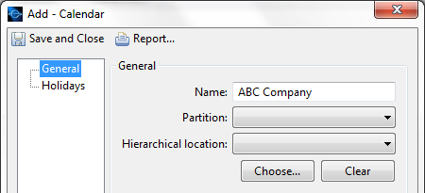

After naming it, click the “Holidays” link in the left pane then the “Add…” button to set the holiday dates within that calendar.

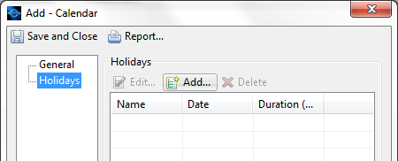

Give the holiday or event a name, and click into the “Date” field to invoke the mini calendar. Choose the day of the event and double-click it. If the event spans multiple concurrent days, choose the first day using the mini calendar, then enter the total number of days into the “Duration” field. Choose the category type (explained on the previous page), and click “Save and Close”.

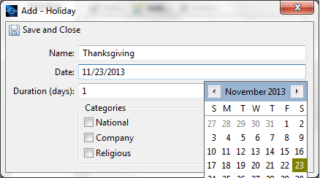

Assigning created calendars to panels:
Now that we have created a calendar of holiday dates for a panel or a group of panels, we now have to assign it to the panel(s). Double-click the desired panel in the hardware tree and choose the “Calendars” link in the left pane. Choose the appropriate calendar in the dropdown list.

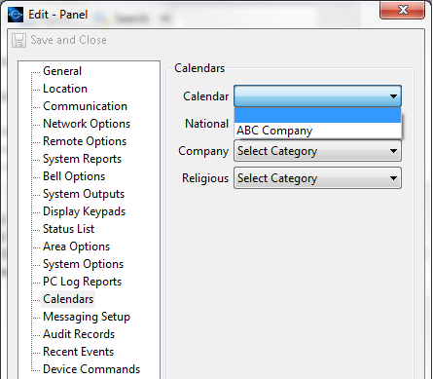

Set the categories to be compatible with DMP panels: “National” = “A”, “Company” = “B” and “Religious” = “C”.

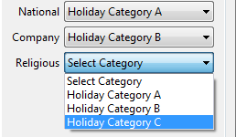

Sending new calendars to panels:
After creating a new calendar record, even though it may have been assigned to a panel, it still has to be sent to the panel(s) in which it will reside. To send calendars to panels, right click the desired panel in the hardware tree, choose “Panel Configuration”, then “Download Configuration…”, then choose the “Schedules” checkbox. The status bar will turn yellow while it’s downloading, then turn green when it’s done. Clicking the “Clear Schedules” checkbox below the “Schedules” box will remove all existing records and replace them with what exists in the Entré database.

*Note:
- Calendars assigned to panels cannot be deleted from the Calendars module

Creating, editing, and running reports

Entré has powerful reporting capabilities built in to every version. At the time of this writing, there are 44 premade templates existing in the software that cover a wide variety of popular reports. Existing reports can be edited to be more relevant to the user’s needs. New reports can also be made from scratch. There are essentially two different types of reports within Entré – SQL-based reports, and filter-based reports. SQL-based reports require at least a working knowledge of the Standard Query Language (SQL), whereas filter-based reports can be created by anyone who understands the Entré software and hardware environment. While SQL-based reports offer much more flexibility and granularity, this guide will focus on filter-based reports.

To access the reports module, navigate to the Management menu and choose the Reports. The existing reports will be displayed. To edit an existing report, double-click it. The window’s title bar (upper-left) will tell you what kind of report it is. (SQL or filter-based). From here, you can edit the name, description, settings, and filter(s).

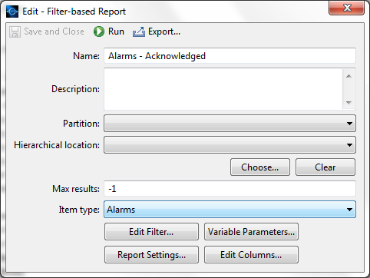

“Item type” is the main or primary filter type. If you wanted to run a report that was primarily about alarms, the type should be about alarms. This would ensure that all data included in the report was at least alarm reports. If you wanted a report about access information, whether alarms or not, the item type should be something else, like “Events”. Clicking the “Edit Filter” button will allow you to further hone the report down to more relevant information. If you wanted to create or edit a report that showed access-granted information by specific door, during a specific time, and by a specific profile, multiple filter items would have to be added.

Creating a new filter-based report:
In the report module, click the “Add” button and choose “Add filter based report”.

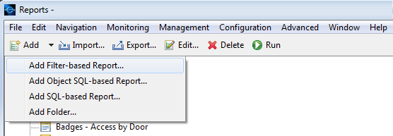
Give the report a meaningful name and choose an item type for the main filter.

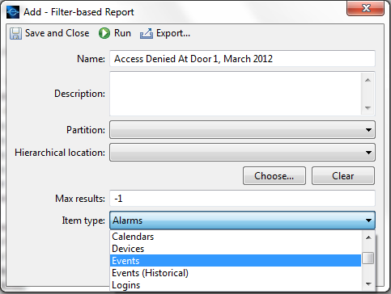

Click the “Edit Filter…” button to add other filter items such as log codes (for certain events), a time frame, a device, a profile, etc. Remember – filter items don’t make the report show more information; they make it show less information.

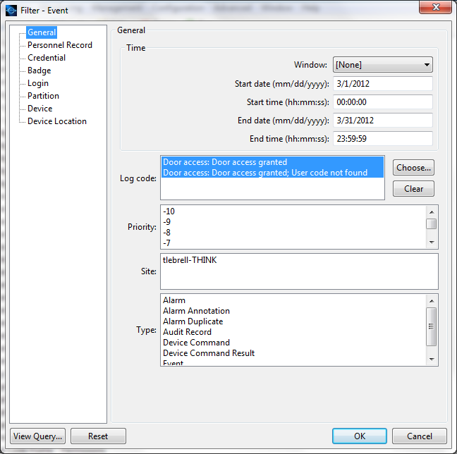

Click the “OK” button when finished editing the filter.
To set the style format (record or tab-style) and the file output type (PDF, Tab-delimited text, or HTML), click the “Report Settings…” button. Reports can be set to saved or opened. “Saved” reports can be found in the “autoexport” folder in the Entré program folder, while “opened” reports can be viewed and saved to any location. Click the “OK” button, then save and close the report editor.
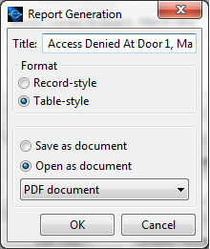

Running and viewing a report:
Reports can be run from within the reports module by either single-clicking the report and choosing “Run” in the toolbar, or right-clicking the report and choosing “run”. The report window will open and display data that will be in the report.

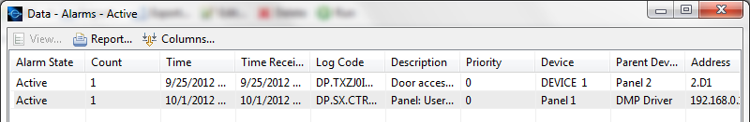

To view the report in its outputted format, click “Report…” in the toolbar. Choose how the report should be formatted and its file-type and click “OK”. The report will open in its default viewer (PDF reader/text editor/browser).
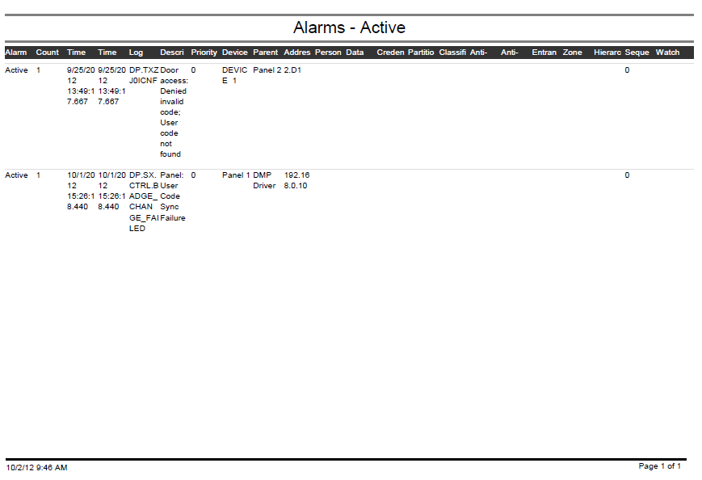
Manual control of security elements from the hardware tree

Arming and disarming areas:
Panel hardware (panels, areas, zones, doors, and outputs) and their statuses are viewable from the hardware module, or “hardware tree”. Areas programmed into a panel for burglary zones and access doors are listed under their respective panels and show their real-time armed/disarmed status. To arm or disarm an area from the hardware tree, right-click the area and make the appropriate choice in the context-sensitive menu.

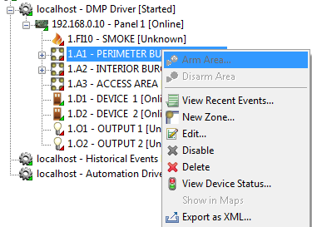

Areas with burg zones (burg areas) will be easy to identify by the collapse control (plus/minus) to the left of the area. Arming and disarming these areas will arm and disarm their respective burg zones. Arming areas that do not have these collapse controls will likely arm “access” areas and could have an unwanted affect on access control. When arming an area, the software will require you to make a 1-in-3 choice of bypassing, force-arming, or refusing to arm the area. This choice is what you want the panel to do when attempting to remotely arm an area that has a faulted zone.

Locking and unlocking doors:
To lock/unlock door controllers from the hardware tree, right-click them and from the context-sensitive menu, choose “Lock” (indefinitely locks door), “Unlock” (indefinitely unlocks door), or “Momentary Unlock” (momentarily unlocks the door for the duration of the strike time programmed into the controller, 5 seconds by default).

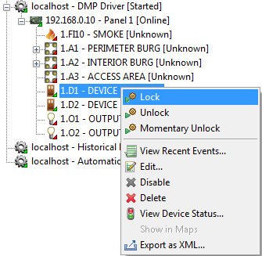
User Code Profile Explanation

One of the unique and useful features of Entré, is that the operator has the ability to administer user code profiles in a variety of ways. A badge can have multiple profiles that each work on different single panels, or it can have a single profile that works across multiple panels. At the end of the day, what matters most is what the profile is able to do (or not do) at a control panel. In either scenario, it comes down to what permissions and restrictions are given, and what areas the profile(s) can or can’t arm, disarm, and access. Entré greatly simplifies the creation and editing process by relegating permissions, restrictions, arming areas, and access areas to checkboxes. While it’s visually easy to create and edit a profile, knowing how to create one can be a challenge to the uninitiated. Here’s a brief explanation of DMP XR100/500 user code profile programming items.

DMP XR100/500 User Code Profile Summary
ARM – Allows the profile to ARM the areas assigned to the profile’s Arm/Disarm Areas. If deselected, the profile will not be able to arm any area(s).
*NOTE: If the panel is programmed not to require a “Closing” (arming) code, arming the system will be possible without the use of a code.
DISARM – Allows the profile to DISARM the areas assigned to the profile’s Arm/Disarm Areas. If deselected, the profile will not be able to disarm any armed area(s).
- Door-Access Functionality: Profiles without this permission will also not be able to gain entry through any door belonging to an area that is armed.
ALARM SILENCE – Allows the profile to silence an active alarm through the keypad user menu.
- Door-Access Functionality: Depending on the panel software version, profiles without this
permission may not be able to gain entry while the panel bell is sounding.
SENSOR RESET - Allows the profile to reset “latched” devices (such as smoke detectors and panics that went into an alarm or tripped state) from the keypad user menu.
DOOR ACCESS – Allows the profile to access doors belonging to the access areas assigned to the profile’s Access Areas.
- Door-Access Functionality: Profiles without this permission will not be able to unlock doors
with an access credential.
ARMED AREAS – Allows the profile to see the armed status of areas from the keypad user menu.
OUTPUTS ON/OFF – Allows the profile to turn on/off outputs from the keypad user menu.
ZONE STATUS – Allows the profile to see the normal/tripped state of zones from the keypad user menu.
BYPASS ZONES – Allows the profile to preemptively bypass/reset individual zones from the keypad user menu.
ZONE MONITOR – Allows the profile to add or remove individual or grouped zones from the zone monitor list from the keypad user menu. Monitored zones sound and display at keypads when they are tripped in a disarmed mode (“chime”).
SYSTEM STATUS – Allows the profile to see system status info from the keypad user menu.
SYSTEM TEST – Allows the profile to perform a system test from the keypad user menu.
USER PROFILES – Allows the profile to add, edit, and remove user profile templates.
*NOTE: A profile that is able to edit profiles will only be able to edit the fields in that profile that the editing
profile possesses. In practical terms, a profile cannot completely edit a “higher” profile.
USER CODES – Allows the profile to add, edit, and remove user code records.
*NOTE: Newer software versions may allow a user to change their own code even if their profile does not allow editing user codes.
SCHEDULES – Allows the profile to add, edit, and remove panel schedules for areas and outputs.
*NOTE: A user can create schedules for auto-arming and disarming from this menu, but those schedules will not be able to arm/disarm those areas unless “Auto Arm” and/or “Auto disarm have been turned on for the desired areas by the installer.

TIME – Allows the profile to reset the panel’s time/day/date from the keypad user menu.
DISPLAY EVENTS – Allows the profile to display historical panel events from the keypad user menu.
SERVICE REQUEST -- Allows the profile to send a service request message (to the central monitoring station) from the keypad user menu.
FIRE DRILL – Allows the profile to send a fire drill message (to the central monitoring station) from the keypad user menu, which also puts the panel in fire drill mode.
EXTEND SCHEDULES – Allows the profile, while disarming from a keypad, to preemptively choose how long they wish to disarm outside of an arming schedule in 2, 4, 6, or 8-hour periods.
TEMP USER CODE – Restricts the profile’s effective functionality by date. When a user code record is associated to a profile that has “Temp Code” enabled, the user code record will display the “Temp Date” field. If no date is chosen, the default effective time period for that user code record will be seven days from the time the user code record was created. At the expiration of the temp date (midnight), the panel will delete the user code record.
*NOTE: Temp-code users can not edit user codes and profiles, even if their profile has those permissions enabled.
ANTI-PASSBACK – Restricts the profile to anti-passback operation as defined by the door controller hardware and system installer.
EASY ARM/DISARM – Causes the profile to toggle arm/disarm the areas assigned to the profile’s “Arm/Disarm Areas” from a code/card entry.
- Door Access Functionality: Easy arm/disarm will interfere with access operation and should
not be used in an “access” profile.
SHIFT TIME ACCESS (1 2 3 4 ANYTIME) - Choosing a single shift number or multiple shift numbers (anything other than “Any Time”) restricts this profile to the times dictated by corresponding shift numbers belonging to the shift schedules created for the areas existing in the profile’s “Access Areas”. Shift schedules are created in the keypad “Schedules” menu.
RE-ARM DELAY – This time (in minutes) causes the profile to override the armed area(s) late-arm delay time on a disarm.
*NOTE: Area late-arm delay is set by the installer, and is designed to rearm a disarmed area that does not have an arm/disarm schedule.
SECONDARY LANGUAGE – Allows the profile, upon code entry at a keypad, to choose a secondary language choice (French, Spanish).
ARM/DISARM AREAS – Defines which area(s) the profile can arm and/or disarm.
- Door-Access Functionality: Generally speaking, the profile will not be able to access any door belonging to an armed area without granting the profile the ability to disarm that area. The exception would be if the door controller had multiple access area assignments and they were not all armed, and the profile had one of the disarmed areas listed in its access areas.
ACCESS AREAS – Defines which area(s) the profile can access. Door controllers belong to areas.
OUTPUT GROUPS – Defines which output groups the profile will activate on an access-type event. The output(s) in that output group will turn on for the duration of the time dictated by the “Strike Time” programmed into the door module or keypad being used. By default, that time is five seconds.

Helpful Tips
- Burglary areas can easily be identified in the hardware tree by the presence of an “expand/collapse” control to the left of the area. Expanding an area will show its zones.
- A door controller’s programming, and therefore its access (or egress) area(s), can be viewed by double-clicking it in the hardware tree and choosing “Access Device” from the left-hand menu pane.
- When Importing personnel CSV files, make sure that personnel and badge numbers in the CSV file don’t already exist in Entré, or else they will be rejected.
- Automation Rules can automate many functions in Entré and therefore also in DMP panels. An automation rule can run a specific report every morning, or lock 100 doors on an alarm. It’s important to remember that panel functions depending on automation rules are dependent on the reliability of the network and Entré environment.
- A well-designed quick-launch panel can make Entré very easy to use for operators of any skill level.
- Most modules can be searched and filtered for specific information.
- Disabled or inactive personnel, badge, and profile records are hidden by default by their respective filters.
- Entré shows a finite number of records in any module, defined by a filter setting in each module called “Max Rows”. This is set to 100 globally by default.
- Events that are no longer viewable in the events module are not gone. They can be searched from the events module, and reports can be run on them.
- The web client’s GUI is “streamed” via network to a web browser. Because the entire GUI is already being streamed, graphics-intensive functions such as maps, event photos, and badging are not supported by the web client.
- If a customer needs to be able to change a personnel record, badge, profile, or schedule, they need a standard or web client. Doing so from a keypad will create inconsistencies in the system.

Good Practices
- Connect to and retrieve a new panel that already has codes, profiles, and schedules, then “Stop” the connection until all of the initial schedules and profile/badge/personnel records have been entered. Failure to stop the panel before profile/badge/personnel programming will cause Entré to overwrite working code/profile records in panels that have those items already programmed-in.
- Log out of Entré if you’re not at your client – Entré has the ability to affect hardware in the field. If someone other than you needs to affect a change, they should do so with their login.
- Consult with an IT or technical staff person before allowing or performing Windows or Java updates on the Entré server.
- Changes made to existing code/profile/schedule records will automatically send to the panels. Allow those changes to send automatically to all panels – manually sending changes while they are already automatically sending can overload the DMP driver if multiple panels are involved.

Pitfalls to avoid
- Never give a badge more than one profile that works on the same panel. While it’s perfectly acceptable to assign multiple profiles to a single badge if none of those profiles exist on the same panel, assigning multiple profiles that exist in the same panel will cancel out those profiles’ effectiveness on that panel. Remember: profiles don’t just say what a code CAN do, but also what it CAN’T do. A profile that has access to only area 1 also says that it DOESN’T have access to areas 2-32. Therefore giving two profiles to a badge - one that only has access to panel 1, area 1, and another profile to that only has access to panel 1, area 2 – will not give them access to areas 1 and 2 on panel 1, because the first profile says that area 2 is not allowed, and the second profile says that area 1 is not allowed.
- Do not give the same schedule to multiple areas/doors that need to have different holiday exceptions. Holiday exceptions are applied to schedules, not areas or doors.
- Do not attempt to add a panel that has not been properly configured to integrate with Entré
- Do not attempt to add a panel that is running an incompatible software version (205 and older)
- Do not arm the panel if it has access control; arming the entire panel will arm the access areas, which may have an adverse affect on access control functionality for some or all users. Arm individual areas instead.
- Do not give an end user a profile that will allow them to edit user codes, profiles, or schedules. Doing so will enable them to create user-data in the panel that will not be retrievable from Entré and therefore will not exist in the Entré database.
- Do not “disable” a panel in the hardware tree, then re-create that panel, and then go back and re-enable the disabled panel. Doing so will cause a duplication of acct and panel numbers.
- Choosing “Clear Codes” on a manual download will clear user code 1, which may be an ambush code.
- “Disabling” hardware from Entré Central Station software also removes it from the panel.

