Cradlepoint Configuration.

1. Factory Default Cradlepoint
   1. System > System Control > Device Options
2. Go into Administration and router security
   1. System>Administration>Router Security
   2. Change the password to tech code 65535
   3. Save
3. Go to Security on left Tool Bar
   1. Zone Firewall > Filter Policy
   2. Change Default to Deny All
   3. Save
4. Go to Options and uncheck Anti-Spoof
   1. Save
5. Go to Port Forward and add a new rule
   1. Flex
   2. Ports 6000 -> 9000
   3. 192.168.0.1
   4. UDP
   5. Save

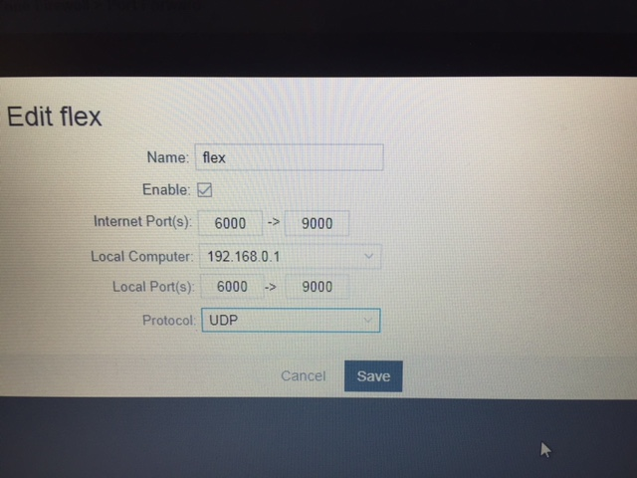

1. Go into Networking
   1. VLAN Interface
   2. Remove WAN
   3. Edit Lan
   4. Add Port 1 into LAN ports
   5. Save
2. Go to Local Networks > Ethernet ports
   1. Edit
   2. Change link speed from Auto to 100FD (both port 0 and 1)
   3. Save.
3. Go to Local IP network and Delete Guest LAN
4. Edit Primary LAN
5. Click IPv4 Settings 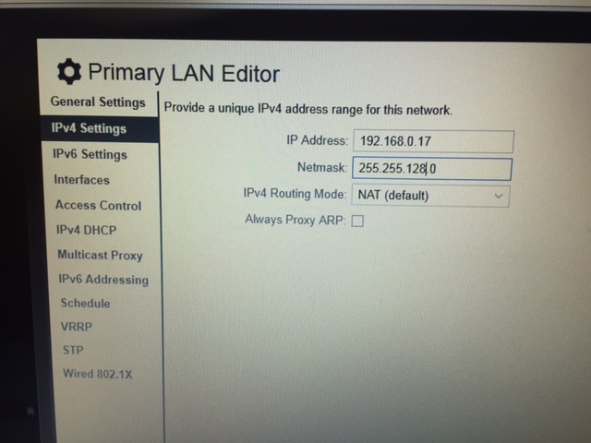
6. Save

Once saved and rebooted, you can go into System>System Control > NetCloud OS and Download Setting to create a config file to upload into other Cradlepoints.